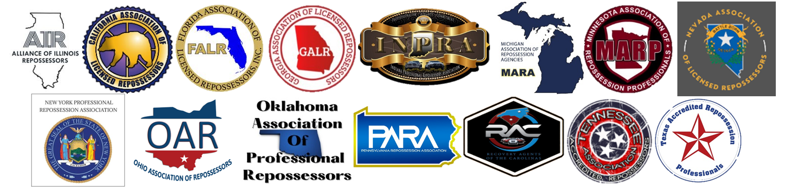

Repossession Industry Best Practices for Documenting Violence Against Recovery Agents

1. Immediate Incident Reporting:
- Ensure all recovery agents are trained on the importance of reporting incidents immediately after they occur.
- Establish a clear, accessible digital reporting system for agents to use.
- Best practice is to have a form or platform where agents are guided through specific criteria that must be included in the report.
- Examples of incidents that should reported include but are not limited to:
  - Drove off wheel lift or attempt to drive off wheel lift.
  - Blocked in by borrower or third party.
  - Violence or violent threats.
  - Weapon brandished or threat of weapon.
  - Police involvement.
  - Breach of peace from borrower or third party.
2. Detailed Incident Documentation:
- Record all pertinent details of the incident, including date, time, location, and VIN #.
- Document the names of all involved parties and witnesses if possible.
- Capture a detailed narrative of the events leading up to, during, and after the violent act.
3. Photographic and Video Evidence:
- Recovery agents should use body cameras or vehicle-mounted cameras to capture video evidence of the incident, ensuring the equipment is properly maintained and operational.
- Take clear photographs of any injuries, damages, and relevant surroundings.
4. Law Enforcement Involvement:
- Report all violent acts to local law enforcement immediately.
- Obtain a copy of the police report or the report number for company records.
5. Medical Attention and Documentation:
- Seek immediate medical attention for any injuries sustained during the incident.
- Keep detailed medical records and reports of any treatments received.
6. Internal Review and Investigation:
- Conduct an internal review and investigation of the incident, led by a designated safety officer or manager.
- Collect and review all available evidence, including reports, photographs, videos, and witness statements.
7. Promptly Report Incident to Client:
- Report incident to client following their required process.
- Send an invoice to the client for the full repossession.
8. Training and Education:
- Offer regular training sessions for recovery agents on how to handle violent situations, de-escalation techniques, and proper documentation practices.
- Education and communication with clients on the risks that agents encounter in the field
By adhering to these best practices, repossession companies can effectively document and address violent acts against recovery agents, thereby enhancing safety, accountability, and professionalism within the industry.

