**SITUATIONAL AWARENESS &  
CNFRONTATIONAL AVOIDANCE   
TECHNIQUES**

**Presented by:**

**EAGLE GROUP XX CE 4 Hours**

**Ron L. Brown MCE, IFCCE, CARS, MPRS, CCCO, CFA**

**Copyright Eagle Group XX 2020 ©**

**In today’s turbulent and ever changing credit and collection industry there goes a person challenged with the task of locating and recovering mortgaged property covered by a defaulted security agreement. This thankless task is without any doubt the most invasive action in the lending process and to perform this task without injuring themselves or consumers, without violating the statutes of the numerous and onerous personal privacy laws takes a very special breed of men and women.**

**Known by many titles including Asset Recovery Specialist, Recovery Agent and the most well “Repo Man” this group must daily come into contact with consumers and with each contact there is the possibility and probability of injury or violence.**

**The Situational Awareness and Confrontational Avoidance Techniques (SACAT) is the collaborative effort of the men and women who are members of Eagle Group XX to create a uniform training program dedicated to making the repossession process a little safer for both the recovery agent and the involved consumers.**

**OVERVIEW**

* **Situational Awareness**
* **Ladder of Force**
* **Recognizing the 4 Types of Anger**
* **Keys to De-Escalation**
* **Safety of Body Space**
* **After Incident Reports**

**SITUATIONAL AWARENESS**

**Situational Awareness is one of the most important traits that a professional asset recovery specialist must develop in order to perform their tasks in an environment safe from hazards and violence.**

**WHAT IF**

You could predict violent encounters seconds before they occurred… and had the skills and knowledge to avoid any issues through neuro linguistic management and control techniques?

**Surprise Kills**

What if…You could avoid being surprised by the actions of consumers or bystanders?

What if…You could recognize and understand **“pre-incident indicators” and react to them accordingly, avoiding confrontations?**

**Obtaining and utilizing this vital information and skill set will provide a safer environment for both you and the consumers and third parties you come into contact with.**

**SEE…**

**Search**: **with your eyes and ears to obtain a full recognition of your environment**

**Evaluate**: **the risk level at that given point in time in relation to “another time/another place”**

**Execute**: **the decision you make in relation to proceed or not proceed**

**By utilizing the SEE skill set on each assignment you will have a better understanding of your environment and increase your safety factor as well as the consumer’s safety factor. Remember SEE is not a now and then thing… use the SEE skill on every assignment**.

**KEYS TO SITUATIONAL AWARENESS**

**FOCUS** attention on the current situation

**FOCUS** on what does and does not belong

**SEE**…don’t just look

Develop a **“SA ATTITUDE”** which is proactive in identifying danger signs

**AVOID DISTRACTORS** such as cell phones, other people, loud noises, etc.

**SA ENVIRONMENT**

**Attention must be paid to your immediate and surrounding environment as this environment is the critical factor which controls the level of your awareness**

**High Alert/Low Alert**

You should be aware of the fact that there are different levels of high alert and low alert, but **ALWAYS** be alert.

**Situational Awareness** requires that you understand the totality of the situation…the **“Big Picture”** as many people tend to stress it.

A professional asset recovery agent must constantly assess and reassess the situation as mitigating factors are constantly changing.

**PRE INCIDENT INDICATORS**

Pre Incident Indicators may usually be classified as **“Obvious”** or

**“Subtle”**.

**OBVIOUS:** Loud and threatening voice

Clenched Fists

Space Invasion

Other people arriving on site

Picking up anything which may be used as a weapon

**SUBTLE:** Rapid Eye Movement

Nervous twitching

Reddening of the face

Tearing up

Looking down

**Intuitive Recognition**…trust your instincts as they are usually right

**Gather Information** using the SEE technique and process it rapidly

**Constantly Play** the “what if…what if not” game and be prepared

**SURVIVOR SIGNALS**

**This are the things that alert you of imminent danger and may possibly save your, or someone else’s life…**

**Suspicion: doubt, misgiving, distrust, appearances are not reliable**

**Apprehension: anticipation or perception of adversity, trouble or a threat**

**Fear: a distressing emotion aroused by impending danger, to be uneasy**

**Out of the ordinary: things just do not feel right as if something is missing or out of place**

**That instinctive “feeling”: a natural aptitude or gift, an intuitive power**

**“It is far more prudent to be cautious than careless”**

**SITUATIONAL AWARENESS E&E**

**ESCAPE & EVADE**

**Have a plan with an exit strategy:** Know what you are going to do if the consumer becomes physically violent, threatens you with a weapon, goes into his dwelling to get a weapon, etc.

**Know the escape routes:** Look at a map prior to working the assignment and know how you can exit the area and always have a “plan B”

**Know where the cover and concealment areas are located:** Know prior to an incident where you will go to seek cover and assistance if the consumer becomes violent

**The ESCAPE and EVADE issue is one of the most important parts of the recovery agent’s skill set and is a very dangerous area as we all tend to forget this item under pressure and the eminent possibility of violence.**

**SUMMARIZING   
SITUATIONAL AWARENESS**

**The professional asset recovery specialist must recognize the fact that bad things can occur and prepare for them**

**The professional asset recovery specialist must constantly maintain a focus on the present…not the past…prepare for the future**

**The professional asset recovery specialist must adapt their level of alertness to the level of their environment**

**The professional asset recovery specialist must pick up on pre-incident indicators and listen to and trust their intuition**

**The professional asset recovery specialist must always formulate contingency plans for all situations**

**“In the end you can’t do much if you don’t see it coming…”**

**UNDERSTANDING THE LADDER OF FORCE**

**Also known as the “USE OF FORCE CONTINUUM” this knowledge is of great value to a professional asset recovery specialist and the following guidelines should be part of the Situational Awareness and Confrontational Avoidance Techniques Skill Set. Force Continuum is broken down into four levels with explanations and responses as follows:**

**LADDER OF FORCE LEVEL 1**

At **Level 1** a subject uses **VISUAL INDICATORS**. In other words, you will feel that there is possible danger based on things that you see: a suspicious subject approaching you, somebody who is looking around nervously, a car slowing next to you. At that moment no laws are being broken by the subject, none that you may be aware of, but you know something is wrong, so you prepare yourself mentally for all possibilities. First you take on a **CONFIDENT DEMEANOR** This means that you look confident and not afraid. Your facial expressions indicate that you are aware of your environment and know how to use it to your advantage. **CONFIDENT DEMEANOR** also means that you look like you are prepared for an encounter or you are aware of the danger and you are making a **“TACTICAL RETREAT.”**

**LADDER OF FORCE LEVEL 2**

At **Level 2** things start to heat up. The subject is actively engaging you or others around you, through **VERBAL INDICATORS**. This can be anything that warns you that an attack is about to happen, but short of direct threats. The conflict cues can be anything from the subject’s tone of voice to implied threats, or even things you overhear – such as others in close proximity whispering about how “there is going to be a fight.” Those are not alarming words in and of themselves, but with some visual indicators one might suspect a possible physical attack. If a subject is trying to start a fight with you the best thing to do is to try to calm that person down or ignore them altogether. This is known as **VERBAL DEFLECTION**. By reacting in this matter you will not incite the situation any further. However, in some situations you may have to use a firm, confident voice to talk some subjects down. You may have no choice but to try to intimidate them, and try to resolve the conflict in this manner. Words will not hurt you physically, but words will be a good indicator that it may escalate to a physical confrontation.

**LADDER OF FORCE LEVEL** **3**

At **Level 3** we enter into actual physical contact with the subject or multiple subjects. It may be a precursor push, or a punch to the nose, or it could even be a sexual touch (sexual battery). It’s at this level where most physical defense systems teach the cookie cutter approach. If someone simply pushes you to intimidate you or to get you to swing first you cannot launch a side kick and blow their knee out, then come crashing down on them with a drop knee to their spine. If you do, even though you have a right to defend yourself, you would most likely be going to jail. This would be **“unreasonable** **force”** for the situation.

At **Level 3** you can get injured: a broken nose, cuts, bruises, scrapes, soreness, etc., but they are neither serious or life threatening. If the subject throws a few swings at you because you’re attempting to repossess his vehicle you can’t rip his head off – the law won’t allow you to do that, even if you did sustain minor injuries from his blows. Because there are not hard and fast rules on what you can and cannot do in a self-defense situation, the law will judge you by a simple rule: **What would a reasonable person do in the same situation?** The law enforcement officer who questions you knows what is reasonable or not, and the jury who listens to you will determine what is reasonable or not. By the way, law enforcement officers are not judged by what a “reasonable person” would do in the same situation, but rather, what a “reasonable peace officer” would do, because they are bound by a lot of restrictions that civilians are not.

**LADDER OF FORCE LEVEL** **4**

At **Level 4** death or serious bodily injury is likely to result, whether the consumer’s, or yours, or someone you are trying to protect. If a suspect does attack you where death or serious bodily injury is likely to result (FELONY ASSAULT), then you have the right as a citizen to use DEADLY FORCE. This not only applies to felony assaults against you, but those you choose to protect. If someone is trying to harm you or co-worker in your presence, you may (but are not required to) use deadly force. However, if the case goes to court, you will still be judged based on reasonableness of the force.

Examples of felony assault include attempted murder, mayhem (putting out an eye, severing a limb, ripping off an ear, etc.), rape, caustic chemical attack, robbery, etc. In other words, and remember these words carefully, **you must have fear for your life, or the life of another.**

When we start off with **Level 1**, there are multiple options: you can walk away, call the police, yell for help, etc. However, by the time you are engaged in a life-and-death conflict there are limited options. If someone is trying to stab you, you have basically one option – control the weapon. If you don’t block the knife or grab the hand that controls it, you could be dead.

**LADDER OF FORCE**

**ACTION=Felony Assault REACTION=Lethal Force**

**ACTION=Physically Combative REACTION=Reasonable Response**

**ACTION=Verbal Confrontation REACTION=Verbal Deflection**

**ACTION=Demeanor REACTION=Visual Confrontation**

**4 TYPES OF ANGER**

**In the course of a professional asset recovery specialist’s daily environment it is possible and most probable that they will encounter anger in many different forms. The repossession of mortgaged property is without a doubt the most invasive process in the credit/lending industry and no one wants to shake the hand of the “REPO MAN”. Recognizing the levels of anger and the potential for violence in each one is another very valuable skill set the recovery agent should possess and use to prevent injury or harm to himself, the consumer and possibly innocent third parties. Let us examine the four basic levels of anger by first looking at the definition:**

**ANGER: A strong feeling of displeasure and usually opposition toward someone or something. A feeling that makes someone want to hurt other people because of something perceived to be wrong or bad.**

**Now let us examine the four major types of anger:**

**Wrath**

**Indignation**

**Rage**

**Fury**

**WRATH**

**Verbally Polite**

**Snipes at You**

**Try to Trap You**

**Writes Letters**

**Try to Cause Trouble**

**Can Escalate to Indignation and/or Rage**

**INDIGNATION**

**3 Phases**

**Nonverbal / Nonphysical**

**Verbal / Nonphysical**

**Verbal / Physical**

**RAGE**

**Physical and Violent**

**Yelling and Screaming**

**Lasts 5 to 120 seconds**

**No Reasoning**

**May Possess Superhuman Strength**

**Non-Cognitive**

**Most Violence Occurs Here**

**FURY**

**Most Dangerous Type**

**Very Cognitive**

**Hard to Recognize**

**Planned and Rehearsed**

**Borders on Madness**

**CONFRONTATIONS**

**AVOID IF AT ALL POSSIBLE**

**Attorney fees start at $10,000.00**

**Remember more and more people possess weapons and will use them**

**Any type of confrontation can be met with anger and embarrassment**

**Family members and friends can get involved**

**Some reactions are out of the fear of not knowing what to do**

**DE-ESCALATION**

**Always start with“I”…**

**Never start with“You”**

**Never criticize or scold**

**Never disrespect”**

**Never try to reason with an angry person**

**Paraphrase their statements**

**Empathize but do not sympathize**

**Never give advice**

**Do not threaten or try to intimidate**

**Remember the “Golden Rule”**

**Use “Feel and Felt” phrases**

**BODY SPACE PARAMETERS**

**A professional asset recovery specialist must always be prepared for any adverse situation which might arise during or after a recovery of mortgaged property has been accomplished and a portion of that awareness is commonly referred to as BODY SPACE PARAMETERS where a recognized factor is that “Action is faster than Reaction”. A beginning point for this skill set is recognition of the three zones of threat and the potential for violence and injury in each zone.**

**THREE ZONES OF THREAT**

**Intimate: 1.5 foot or closer constitutes an invasion of your space and is usually felt to be intimidating or uncomfortable. Violence resulting in injury or death id very easily accomplished at this distance and should be avoided if at all possible.**

**Personal: 1.5 foot to 4 foot is usually the distance the recovery agent will find themselves in when speaking with someone regarding the recovery assignment. At this distance the agent must remain very alert and realize the precursor signs for potential violence.**

**Social: 4- foot plus is a favored distance and offers the recovery agent the best opportunity to defend themselves or escape an escalating enviroment.**

**NO MATTER WHAT DISTANCE… BE ALWAYS ON THE ALERT**

**HOW SHOULD I REACT TO A PHYSICAL CONFRONTATION???**

**THE FIGHT IS ON…**

The recover agent may find themselves in a volatile situation regardless of their efforts to avoid a confrontation. What are the options when you are suddenly set upon by an angry consumer who may be using Fists, Clubs, Knives or even Firearms to thwart your repossession attempt?

**RUN FORREST RUN**

**Defensive weapons only:**

**Pepper Spray**

**Flashlight**

**Note Pads**

**Keys**

**Kevlar Gloves & Vest**

**BEWARE OF EDGED WEAPONS**

**Knives and any type of edged weapon can be very deadly and here are a few facts that the a recovery agent should know:**

**30% greater risk of death by knife than firearm**

**21 ft Rule**

**12 ft in 1 second**

**6ft in .5 second**

**Approach and stand on the weak side…never the front**

**Be aware of surroundings…people and things**

**Assess the scene…know the exits**

**21 FOOT RULE**

A rule originating from research by Salt Lake City trainer, Dennis Tueller, the "rule" states that in the time it takes the average officer to recognize a threat, draw his sidearm and fire 2 rounds at center mass (1.5 seconds), an average subject charging at the officer with a knife or other cutting or stabbing weapon can cover a distance of 21 feet.

**Discretion is always the better part of valor and the professional recovery agent should always retreat from any situation where weapons are introduced or where the potential for violence is eminent. Not only is it the smart thing to do but courts have recognized that the recovery agent has a “duty to retreat” if there is an objection to the repossession.**

**Defensive Knife Wound on Hand**

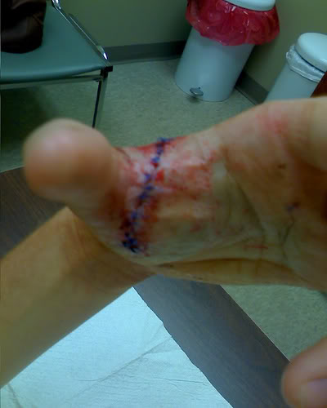

**IN THE BLINK OF AN EYE**

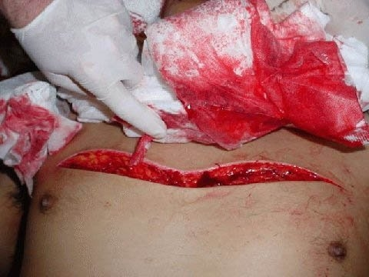

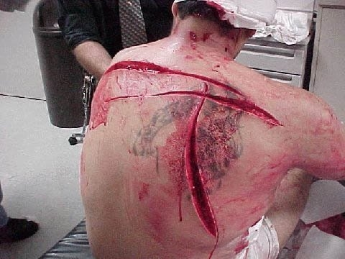

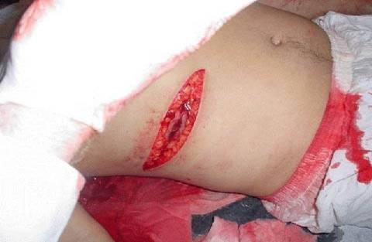

**AVOID THIS TYPE OF INJURY… AVOID CONFRONTATIONS**

**AFTER THE FACT**

**Recovery Agencies and their agents should keep up to date training records to indicate and document knowledge of de-escalation techniques as well as company policy regarding confrontations.**

**These record may indicate that you have been trained and possess the skill sets to avoid confrontations and that you have a clear understanding related to the need for use of force.**

**If you are involved in any type of confrontation immediately document the events as they occurred and Indicate that you exhausted all means of communication and de-escalation.**

**Remember the details and write them down in a clear and concise manner.**

**DOCUMENTATION**

**Remember the old adage “If it is not documented it did not happen” so document, document, document.**

**Your documentation should contain the following information:**

**Date and time of contact**

**Length of contact**

**Course of events**

**Witnesses**

**Develop a “form” and utilize it on each confrontation.**

**KEY REPORT OBSERVATIONS**

**It is imperative that you and others who may have been involved put observations and actions into writing as soon as possible while the incident is fresh in each person’s memory. Time-Date all Documents and have the author sign them.**

**Be certain your documentation includes the following:**

**PRIMARY ENGAGEMENT: heated, calm, controlled**

**CONSUMER’S BEHAVIOR: angry, passive, evasive**

**YOUR RESPONSE: verbal, physical, combative**

**ACTION: steps you or others took to avoid a confrontational situation**

**SUMMARY AND KEY POINTS**

**Closeness = Threat**

**Constantly assess situation**

**Remember body space parameters**

**Do everything possible to avoid use of force**

**Use force only for self defense**

**Be prepared to articulate actions**

**Document Everything**

**Situational**

**Awareness and**

**Confrontational**

**Avoidance**

**Techniques… allow you to**

**“Live Long and Prosper”**

**…Spock**